**Event Management Output**

**Login Page**

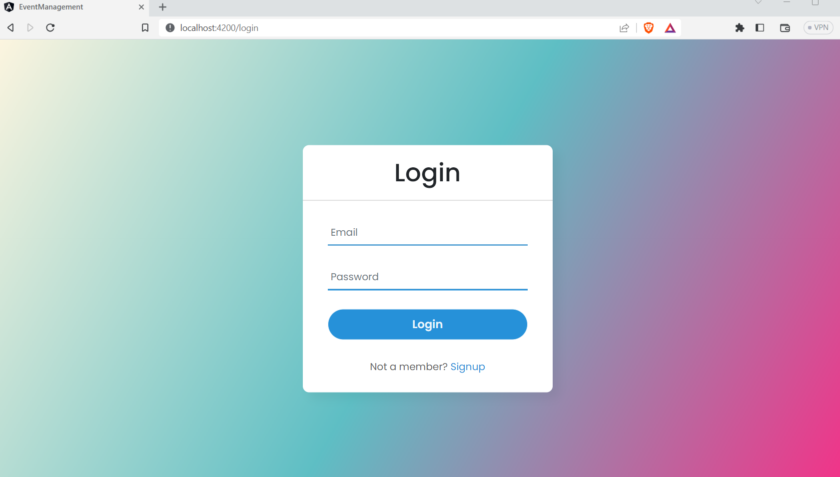

**Successfully login Page**



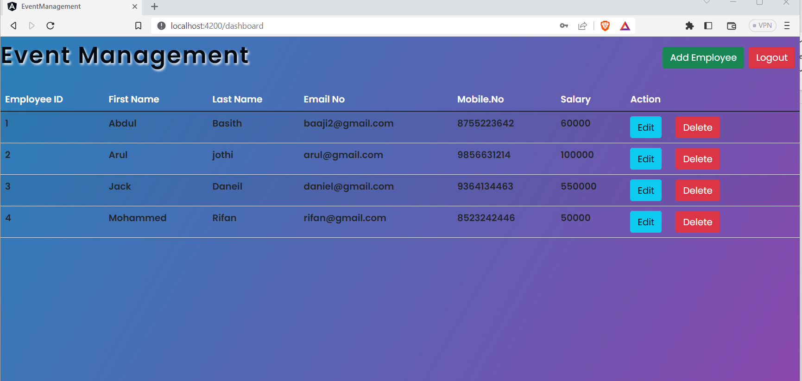

**Db.json**

{

  "employees": [

    {

      "id": 1,

      "firstName": "Abdul ",

      "lastName": "Basith",

      "email": "baaji2@gmail.com",

      "mobile": "8755223642",

      "salary": "60000"

    },

    {

      "id": 2,

      "firstName": "Arul ",

      "lastName": "jothi",

      "email": "arul@gmail.com",

      "mobile": "9856631214",

      "salary": "100000"

    },

    {

      "id": 3,

      "firstName": "Jack",

      "lastName": "Daneil",

      "email": "daniel@gmail.com",

      "mobile": "9364134463",

      "salary": "550000"

    },

    {

      "id": 4,

      "firstName": "Mohammed",

      "lastName": "Rifan",

      "email": "rifan@gmail.com",

      "mobile": "8523242446",

      "salary": "50000"

    }

  ],

  "signupUsers": [

    {

      "fullname": "ABDUL KADHAR N",

      "email": "baaji@gmail.com",

      "password": "123456",

      "mobile": "9788652145",

      "id": 1

    },

    {

      "fullname": "ARUL KUMARAN",

      "email": "arul@gmail.com",

      "password": "123456",

      "mobile": "9783482214",

      "id": 2

    },

    {

      "fullname": "jack daniel",

      "email": "daniel@gmail.com",

      "password": "123456",

      "mobile": "9677362373",

      "id": 3

    },

    {

      "fullname": "dharsan",

      "email": "dharsan@gmail.com",

      "password": "123456",

      "mobile": "6794603486",

      "id": 4

    }

  ]

}

**Edit Page**

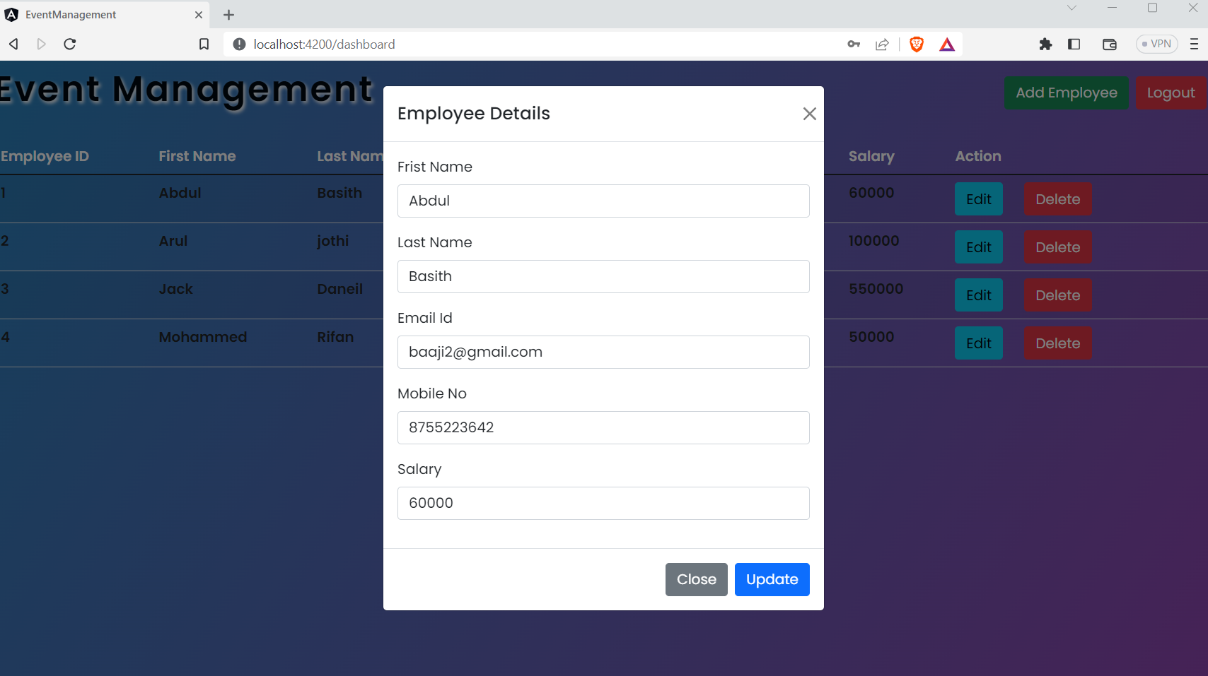

**Add Employee**

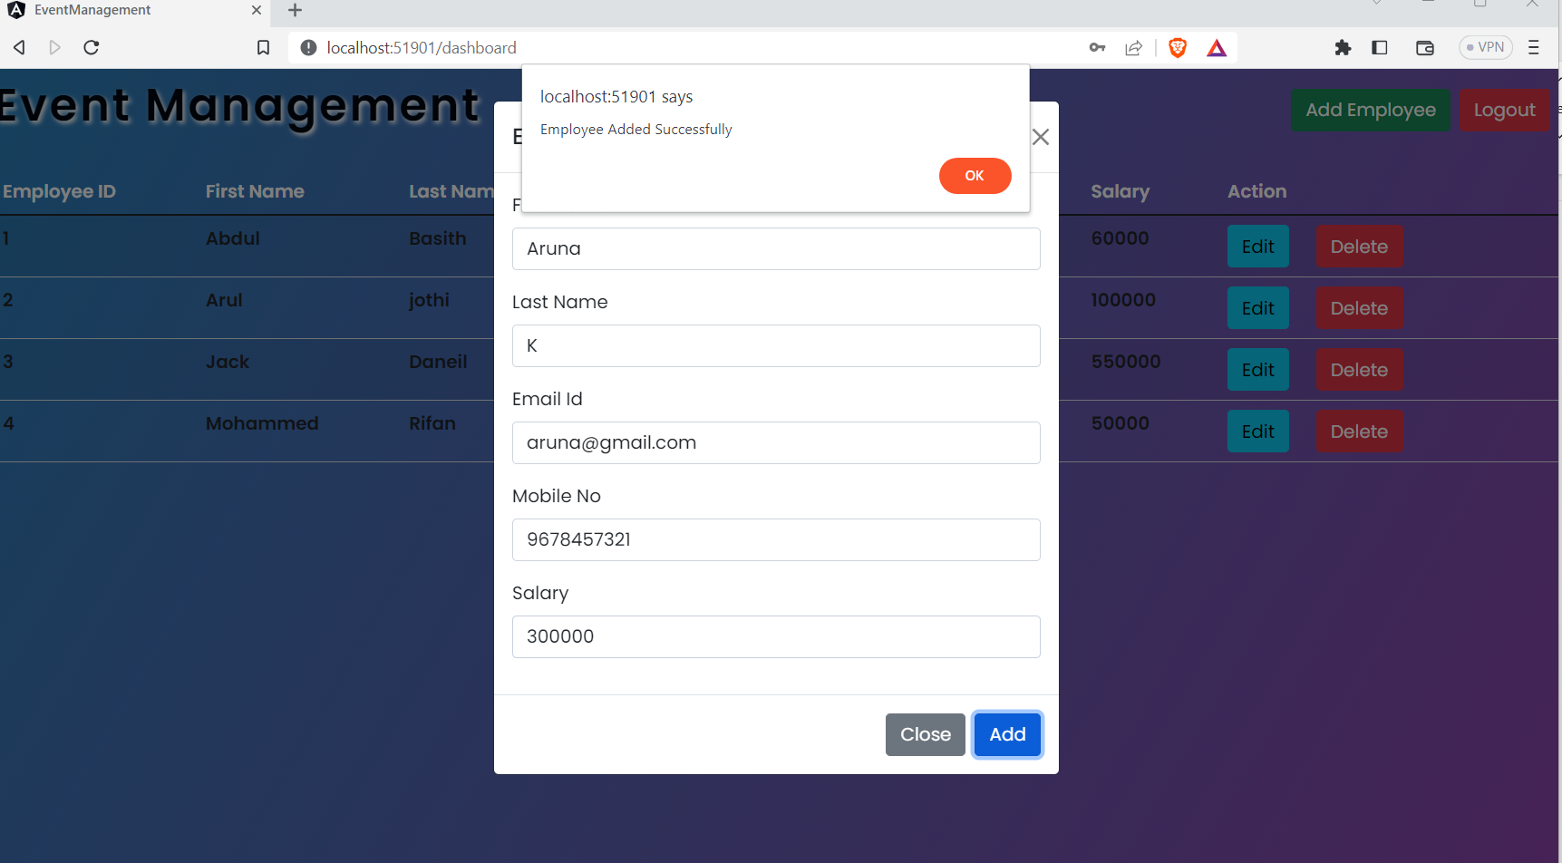

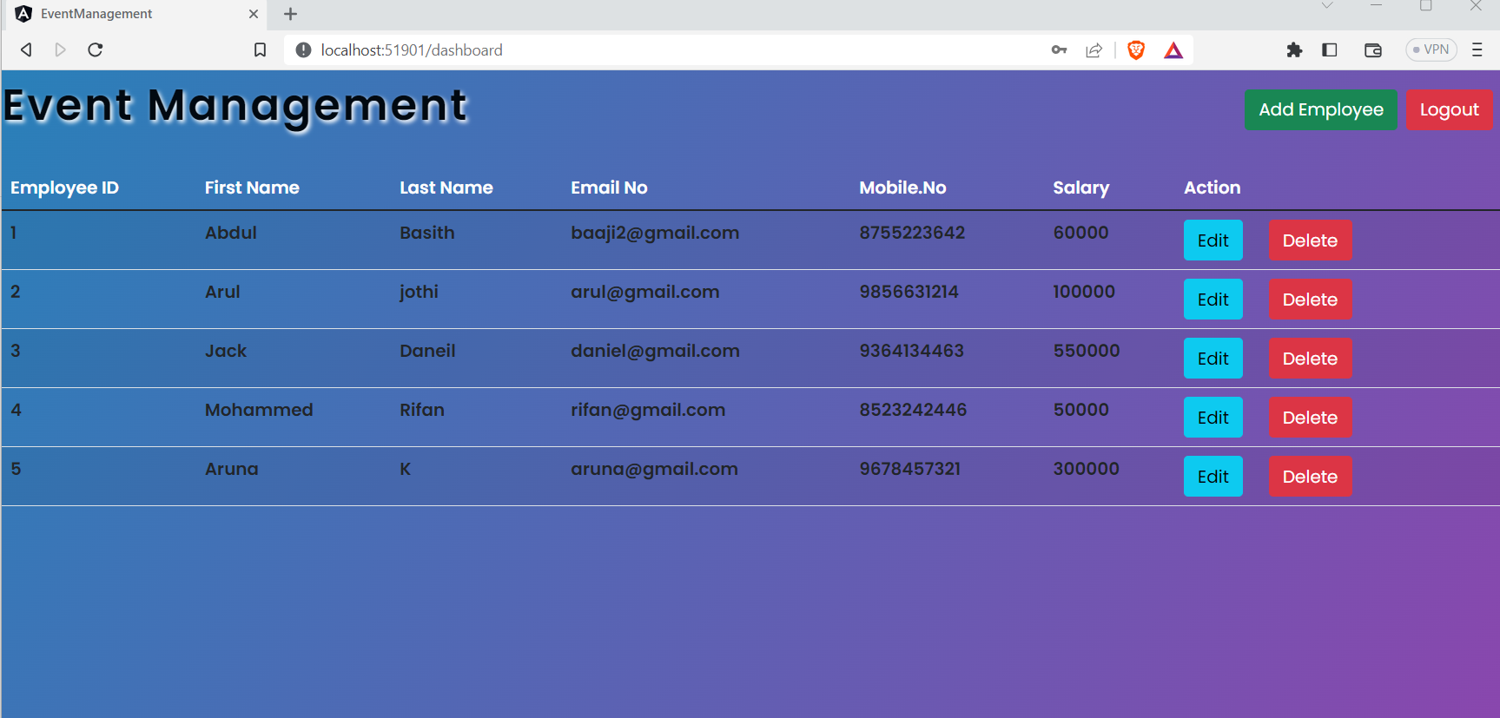

**Signup Page**

